Interactive Animated Problem Sets in Learning Functions and Binary Operations

Martti E. Pesonen and Hanna Lehtola
Department of Mathematics, University of Joensuu, Finland
http://www.joensuu.fi/mathematics/

Abstract
We describe the computer based learning activities meant to extend and reinforce our new students’ understanding of the definitions of function and binary operation, and discuss some aspects of the outcomes, e.g. how the students managed in doing the activities and what they thought about them.

Background
The Department of Mathematics takes care of the mathematical education of secondary and tertiary level mathematics and science pre-service teachers at the University of Joensuu. General education and didactics of mathematics are traditionally taught in the Faculty of Education, but there is a strong tendency to integrate pedagogical issues in the subject studies, too. One aspect aiming to this is the use of computers in teaching and another is more activating and student centered approach, and these two fall together in the way we describe here.
A viable understanding of the concepts "function" and "binary operation" constitute a necessary background for learning undergraduate mathematics. Therefore, we have tried to "implicitly force" the students to rethink the definitions, especially the role of sets; the domain and the range/image.
In October 2001, before they had learnt anything about functions after school, our freshmen had a three hour computer lab where we used an html-form containing Javasketchpad applet based interactive animations combined with problems targeted to clarify different aspects of the function definition. In these worksheet the students can "play" with the mathematical objects, like in e.g. Geometer's Sketchpad or Cabri, but they only have very restricted tools. Tools may be dragging points, controlling an animation with buttons or mixing these two, using dragable segments for measuring or receiving hints or warnings as response to their actions. The pedagogical background comes from the work of Shlomo Vinner & al. concerning "concept images" and concept definitions, combined with the use of verbal-symbolical-graphical representations of concepts in concept formation, which has been investigated for example by my colleague Lenni Haapasalo in the framework of ”locally radical social constructivism”.

WWW-Javasketchpad worksheets
The computer activities were planned to be carried out either as guided computer lab work or as ”homework”, simulating distance learning. Therefore we used html-documents and the Java applet Javasketchpad of Key Curriculum Press, lurking on our www-server. The applet constructions, (dynamical interactive pictures which we call here sketches), and the problems are integrated in the html-form so that the students can send their anwers to the teacher by a single push of the ”Send” button in the end of the document. The answers can be of multiple choice, short input or text area type, and after sending the students’ answers are shown. On this Form Mail document also the correct answers can be shown if appropriate.
A Javasketchpad sketch can contain geometrical elements such as points that can be dragged using the computer mouse, lines, rays, segments, circles and more advanced constructions that can depend on the points or calculations, control buttons for showing and hiding objects or moving or animating them, see Figure 1. The sketch can also contain text and gif-figures. Sketch codes can be generated automatically by Geometer’s Sketchpad or programmed by hand using the construction language, which we have used because of more precise output and control of the command structures. The code is sent as a parameter to the applet, and the resulting sketch is shown by the browser on the computer screen as a part of the html-form which also contains the appropriate problems.

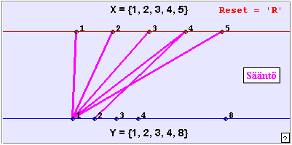
Figure 1. An applet construction

Structure of the whole demo

The Pre-test
The three hour demo was started by a half an hour paper-and-pencil Pre-test to see what the students knew about functions on the basis of school mathematics. Most problems were of definition identification type, using graphical or verbal representations of the candidates. They also had to choose whether the following statements concerning functions are true or not:

- For each value of the variable the value of the function is always different.
- No element of the domain set can be mapped to an element of the same set.
- No element can have more than one image.

Finally they were asked to write down the definition of function as they knew it.
We got the following results:
a) correct 61, wrong 13
b) correct 36, wrong 38
c) correct 46, wrong 27, no answer 1
Function definition was expressed correctly by 18 students, half correct by 19 and wrong by 30; seven students gave no answer.

The Function Demo
The most extensive part of the activities was the interactive computer-based Function Demo, which took about two hours of intensive work In the worksheet the problems range from Venn-diagram-like pictures where arrows show the rule, to traditional coordinate representation in the plane, and finally to parametric vector-valued functions of one real variable. In some problems we asked whether a shown dynamical graphical representation describes a function, and if not, why. In many problems the domain and range were asked for, and in some the function rule itself was asked to be explained using a symbolical formula and/or own words. Another worksheet Function Repetition 2 extends to real- and vector-valued two variable functions and binary operations in the plane.

The Post-test
A week after the computer lab session students had to fill in an online Post-test where again some identification problems were posed. We also asked for a detailed student evaluation of one particularly problematic applet construction in Problem 7 of the Function Demo and some more general feedback. The Post-Test is found at
http://www.joensuu.fi/matematiikka/kurssit/AnalyysiI/Funktiotesti/JKyselylomake.htm
We discuss and compare the results of the Pre- and Post-tests in section 5, after describing the Function Demo itself.

The Function Demo
The Function Demo worksheet is found at
http://www.joensuu.fi/mathematics/MathDistEdu/SemProd/FunktioDemo.htm
We received 74 email answers to the problems, two of which were incomplete because of some technical problems. The worksheet contains 17 Javasketchpad sketches, which fall into different categories according to the following table of contents:

I Definition of function: domain - rule – range (problem sets 1-5)
Definition of function (text)
Different representations 1-4
Bijection 5
II About graphical representations of real functions (problem sets 6-15)
One dimensional axis-to-axis representation 6-10, feedback
Plane curve representation 11-12
Examples (power, root, exp, log) 13-15
III About vector valued functions of a real variable (problem sets 16-17)
Plane curve 16
Motion in the plane 17
IV Student feedback (text area)

Problem sets 1-5
The elementary problems 1-3 were very well done, although in 3a and 3c ten students failed, and a reasonable verbal expression was produced by 2/3. Problems in 4 (see Figure 1) and 5 were solved correctly by about 80%, except the production of verbal and symbolical representations in 4c, 4d and 5c, which were solved by only 30%. Also in 5d, less than half could restrict the domain to get a bijection.
In all graphical expressions the results were better than in the Pre-test.

Problem sets 6-10
In sketches 6-10 (see Figure 2) the function acts between two parallel real lines, the upper containing the domain. All domains are intervals, but values may be intervals, discrete (7), multiple (9) or exceed the real line (10). There are two ways to arrange the restrictedness to an interval, either the variable is bound to an interval or there is no image when the variable goes outside the domain.

In different sketches different tools are available:
6: Function: continuous, periodic; Buttons: animate, ticks, restrict, trace
7: Function: discontinuous, discrete; Buttons: values, ticks, trace
8: Function: continuous; Buttons: values, ticks, trace
9: Relation: two-valued; Buttons: values, ticks
10: Function, not real-valued; Buttons: animate, ticks

The problem sets 6-8 were about properties that they know from school: domain, image/range, values, extrema, monotoneity, continuity. These were successful, in general.
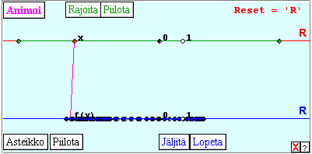
Figure 2. Sketch to Problem Set 6
The most difficult was 7e: ”Is the function continuous?”, less than a half managed. This may be partly because of the strange representation; there are no visible ”gaps”! Also 6f, the image of [0,1], was not managed by some 10%, likewise 7b, 7c and 7d. Problems 9 and 10 were clearly not functions, which 20%-30% (confused?) students could not find out or explain correctly.

Opinions about axis-to-axis-representation
In the middle there was a special feedback part, where we asked for students’ opinions about how well the one-dimensional axis-to-axis representation suit for solving typical real function problems:

1. Function values
2. Domain and image
3. Understanding the trinity domain – rule – range
4. Bijectivity
5. Increasing/decreasing
6. Maxima and minima
7. Boundedness
8. Periodicity
9. Continuity
10. Differentiability
11. Sign of derivative
12. For what it suits especially well/poorly?

Great majority of students appreciated the representation’s suitability for problem types 1, 2 and 6, and in only problem types 8, 10 and 11 more students rated it ”poor” than ”good”.

Problems 11-12
The sketch 11 animates a process where axis-to-axis representation transforms to conventional coordinate system. The functions and problem sets in 11 and 12 are the same, the essential difference is that in 11 the graph ja tracing are not available. Here the results are almost equal and expectedly, differentiability (g and f) is the most difficult problem.

Problems 13-15
In some problems one could get 0, 1 or 2 points, e. g. if there was some extra information in the answer. Both 1 and 2 points can be regarded as ”managed”.
Concrete and familiar power&root, exponential and logarithmic functions were treated in a satisfactory way. Here the sketches contained the variable on the horizontal x-axis, and a parameter (r or a) changing the function was in an extra real line in the lower end of the sketch. The problems were of quite traditional nature and the sketch tool helpful, except that the poor handling of singularities caused some strange effects in the sketch, and the problems of symmetry of graphs raised confusion for the students (see Figure 3).
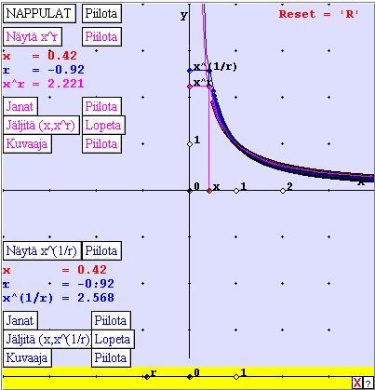
Figure 3. Power and root functions interactively (sketch 13)

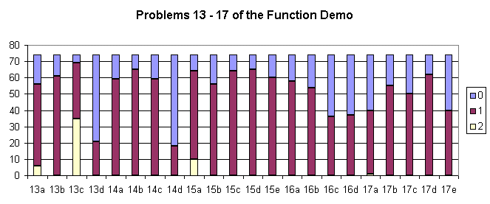
Figure 4. Part of students’ achievements
Remark
By now many students began to be exhausted, and for learning new things this certainly was not the best time. But this was part of the experiment, to see how much they can be expected to stand!

Problems 16-17
The sketches now turn to vector-valued functions. In 16, it is shown how axis-to-axis representation of two functions to separate range lines are turned to the parametric interpretation. Values and pre-images were found by 75%, while half of the students identified the component functions among the given three trigonometric candidates (see Figure 4).
In 17 the same framework is used to illustrate time-depending two-dimensional motion. The problems are very elementary; to measure distances with a dynamical ”ruler” tool and to make sense with ”when the particle is at certain point in the plain”, finishing with dealing with periodicity. At least half of the students managed with all these problems, the measuring being achieved best.

Student Feedback
The lengthy worksheet ended with an open ended Student Feedback text area starting:
”I think that ...”.
In general, the feedback was positive. Most frequent students’ expressions about the demo were:
- good variety, good for a change (19)
- good (15)
- nice (8)
- useful, beneficial (7)
- clear, concrete (6)
- interesting (5)
Students also complained or gave suggestions:
- too much work in one worksheet (19)
- things should be first taught during the course lectures (15)
- the worksheets should contain more: hints (10), theory (6), explanations (5), examples (4)
- animations should be clearer (8)
- improve problem setup (7)
- better feedback from the teachers’ side (7)
- improve user instructions (6)
- improve user interface (4)

Comparison of Pre-test and Post-test
Although the main purposes of the demo were to test the technical and pedagogical functionality of the worksheet and to see how the students manage with it, we also wanted check whether their knowledge and skills seemed to improve.
In both tests there were some nearly similar problems.
Problem type | Pre-test % correct | Post-test % correct
Traditional graph (4K and 1a, two-valued) | 32.4 | 77.5
Traditional graph (4K and 1d, sub-interval) | 32.4 | 43.7
Verbal (2a and 2a, function) | 94.6 | 100.0
Verbal (2c and 2c, not a function) | 8.1 | 19.7
Verbal (2b and 3c, not a function) | 56.8 | 71.8
Verbal (2b and 2b, not a function) | 56.8 | 56.3
Verbal (2d and 2d, not a function) | 74.3 | 59.2

